MSFconsole Fundamentals:

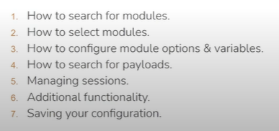

MSF module variables:
Options like target & host ip address and port are configured throught the use of MSF variable.
(local and global variable values)

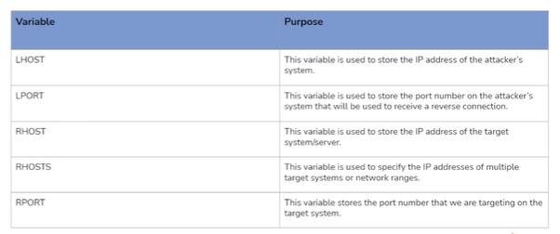

DEMO:

Msfconsole -q
# q means quietly

Help
# show help menu

Version
# show msf version

Show all
# show all available modules

Show exploits
# show all available exploits modules

Show -h
# show help menu of command “show”

Search portscan
# show portscan module

Use (name/index no)
# it choice that module

Show options
# list option for this module

Set RHOSTS target_ip
# set target

Show options

Set PORTS 1-1000
# set port range to scan

Show options

Run
# execute that module
# show the results

Ctrl+c
# to terminate

Back
# to move back

Search -h
# show help menu of search command

Search cve:2017 type:exploit platform:windows
# cve release in 2017 and type that we want is and platform is the target against which we perform that.

Advanced commands:

Search ethernalblue
# it target smb (older version)

Use (indentifier/name)
# to select it

# based on target system and it’s architecture we have to change the payload.

Show options

Set payload name_of_payload
# to set the payload

Set RHOSTS target_ip
Show options
Run/exploit

Background
# to background the session

Sessions
# view the active sessions and their id’s

Connect -h
# show help of connect

Connect target_ip target_port
# Perform the banner grabbing.

NOTE:
Clear = ctrl+l

Banner grabbing is the technique of connecting to a network service and reading its initial response (the "banner") to learn software name/version and other info.

